**JSP Application**

1)Creating Dynamic Web Project:

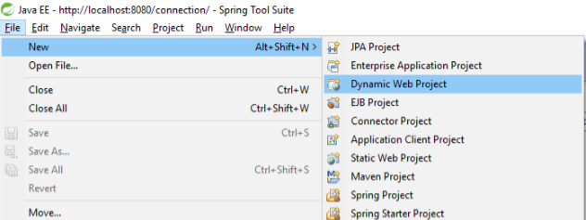

2)Project Structure

Place all jsp files in Yourproject-->WebContent-->WEB-INF--> jsp.

We Can also create our Own folders in WEB-INF with respect to project Requirement.

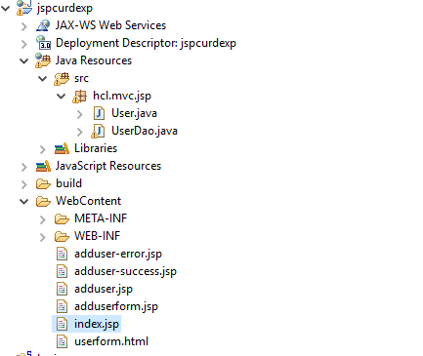

**3)In WEB-INF copy all jar files in lib folder and give required server libraries if need**

Right click on project--> buildpath🡪 add external jars.

[Download jstl1.2.jar file](https://www.javatpoint.com/jsppages/src/jstl-1.2.jar)  
[Download mysql-connector.jar](http://www.javatpoint.com/src/jdbc/mysql-connector.jar)

**4) Java classes**

**1)User class :**

Note: In this keep all required fields and create getters and setters.

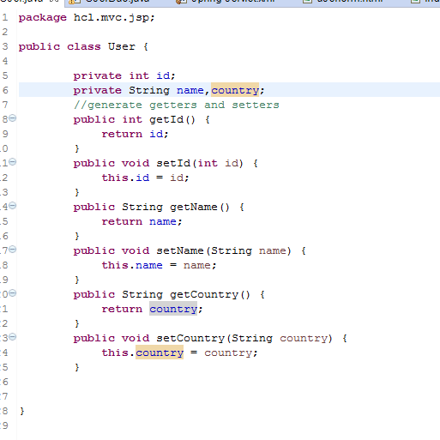

**2)UserDao Class:**

In the following snippet used SQL data base and, mention there information. Or else we can write as a separate static class for data base information for reusing the code.

And we can mentioned SQL operation methods also.

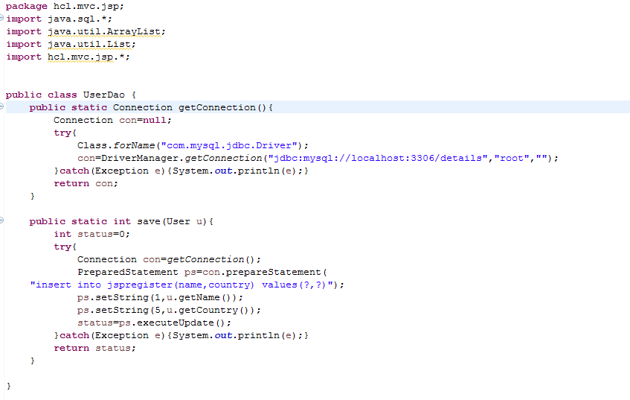

**5) Html page**

Keep all your ***html*** files in WebContent.

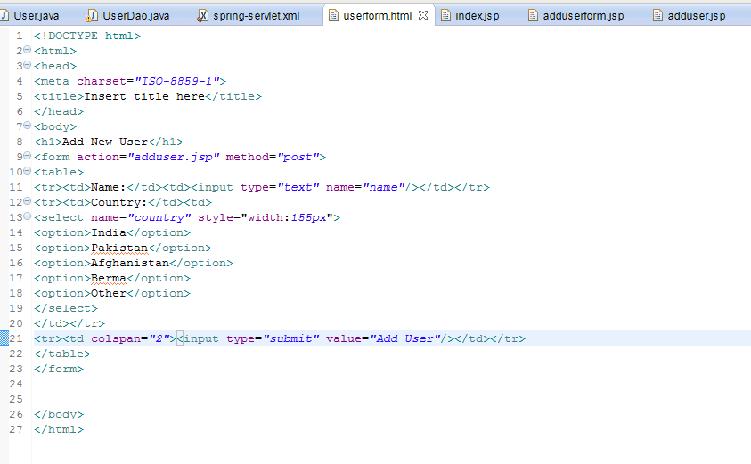

**6) JSP pages**

**1)index.jsp**

In this , it will start from the index page. And in the process linking pages will called.

Index form will cal adduserform.jsp

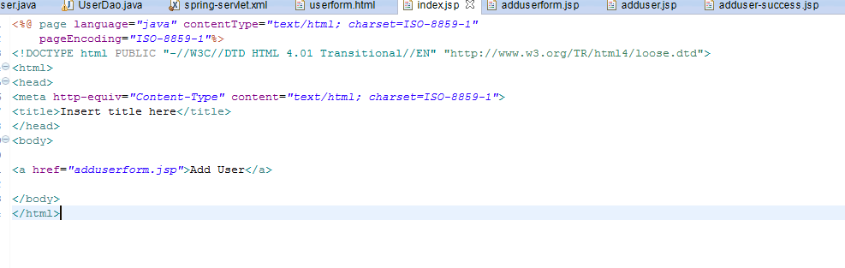

**2)adduserform.jsp**

From this page it will cal html page as userform.html

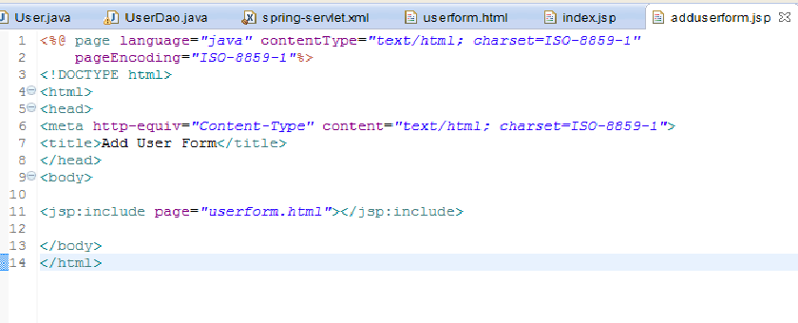

**3)adduser.jsp**

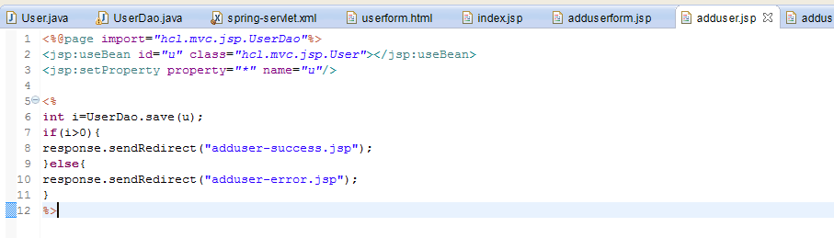

**4)success.jsp**

If you entered currect details it will added to data base

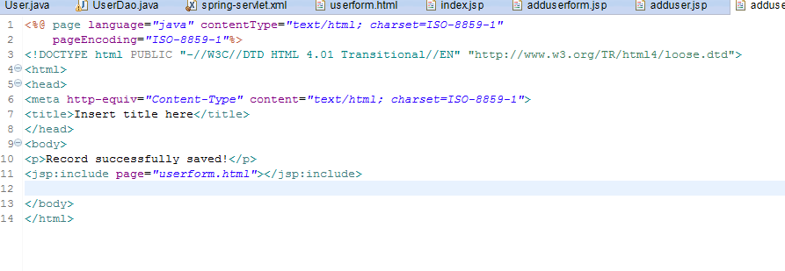

**5)error.jsp**

If you enter type miss match details , then it will be a error.

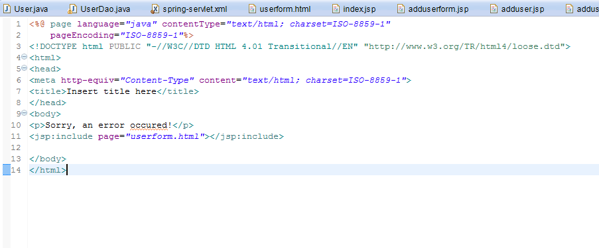

**OutPut:**

